**Symbiosis School, Nashik.**

**Std : X Term I (2020-21)**

**Subject : English Core - Worksheet - 24**

**Lesson 5 : Hundred Dresses Part I By El Bsor Ester**

**Instructions**

Please read the chapter and summary carefully and write the concept based question answers in the English notebook.Write the new words and thwir meanings too.

**Introduction**

The lesson “The Hundred Dresses I” is about a girl named Wanda who claims to have one hundred dresses. Her classmates made fun of her because what she claims is in contradiction to the fact that she was always seen wearing the same dress. Her classmates found her name to be “funny”. It was because everyone had “easier” names than ‘Wanda Petronski’. Her name was different because she was a Polish immigrant who had come to an American town with her family. She was poor and did not have many friends. She was quiet and was always seen sitting in the corner of the classroom. The truth about the hundred dresses unveiled when she submitted her hundred drawings in a drawing contest. They were the same hundred dresses she used to talk about. All of them were immensely beautiful.

**The Hundred Dresses Summary**

The story is about a quiet and shy girl named Wanda Petronski, a Polish immigrant, who had come to America with her family. She attended school with American children who found her name to be strange and probably,  the weirdest in the classroom. This is because they all had easier names. She was poor and was always seen wearing a faded blue dress. Her classmates teased her because she claimed to have a hundred dresses “all lined up” in her closet albeit, always being seen wearing one. The ones who mainly teased her were the two best friends, Peggy and Maddie. Peggy was the most famous girl in school while anyone barely knew Wanda.

Peggy and Maddie used to wait for Wanda before school even if it meant getting late. Maddie, a poor girl herself did not like when Peggy made fun of Wanda. She feared that she could be next. She wanted Peggy to stop making fun of Wanda, but could not summon courage to face her as she feared she’d lose her best friend. However, Peggy’s intention was never to hurt Wanda but she was curious as to why Wanda had to lie that she had a hundred dresses in her closet.

Truth about the same hundred dresses unveiled on the result day of the drawing competition. The room was lined with one hundred drawings portraying different dresses, each so beautiful. That day, she truly had “a hundred dresses all lined up”, but in the classroom. At that moment, Peggy and Maddie, who were awestruck realised the theory of a hundred dresses and felt guilty about having treated her badly

**Word Meanings**

Scuffling of feet- noisy, dragging movements of the feet on the ground

Didn’t hang right- didn’t fit properly

Hopscotch- a game in which children hop into and over squares marked on the ground

Nudge- a gentle push  
Incredulously- showing unwillingness to believe  
Courteous- polite, respectful  
Stolidly- calm, dependable, and showing little emotion and animation  
Shrieks- scream

Exaggerated- overemphasise

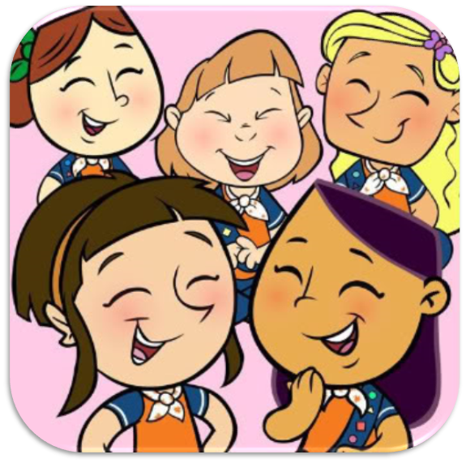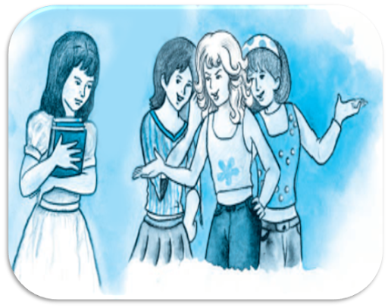

Her eyes dull- having eyes wanting brightness, liveliness, and vivacity

Bullies- someone who hurts or frightens someone else, often over a period of time, and forcing them to do something that they do not want to do.  
Mistreated- to treat someone badly

Absentmindedly- distracted

Shuddered- shake, tremble  
Disguise- to give a different appearance to conceal its identity

Scarcely- hardly; barely  
Trimmings- decoration  
Sash- a long strip or loop of cloth worn over one shoulder or round the waist, especially as part of a uniform or official dress  
Pretended- not genuine  
Admiration- respect and warm approval

Drizzling- rain lightly  
Hurried- quick

Gasped- catch one's breath with an open mouth, owing to pain or astonishment.  
Ledge- shelf  
Windowsill- ledge or sill forming the bottom part of a window  
Dazzling- extremely impressive, beautiful, or skilful  
Lavish- gorgeous  
Murmured- say something in a low or distinct voice  
Admiringly- in a way that shows respect or warm approval

Assembled- gather together in one place for a common purpose

**Concept Based Questions**

**Question 1.**

Describe the reaction of Wanda Petronski to Peggy and Maddie.

**Question 2.**

Why did Maddie write a note to Peggy and then tore it?

**Question 3.**

Explain two dresses of Wanda Petronski in brief.

**Question 4.**

What kind of a girl was Peggy?

**Question 5.**

What was the competition about in the school?

**Question 6.**

Who won the drawing competition in each category? What had they drawn?

.

**Question 7.**

How does everyone in the class react to Wanda’s drawing?